AI Lakehouse Optimization
Metadata-Driven Query Performance Optimization
Proposal Document

1. Problem Statement
Query performance problems in modern data warehouses and lakehouses are diagnosed manually and inconsistently. When a dashboard slows down or a job blows past its SLA, the typical response is reactive: someone opens an EXPLAIN plan, inspects it by hand, and guesses at a fix based on experience rather than systematic evidence. There is no persistent, queryable record of how SQL workloads actually behave over time, which means every optimization decision is made from scratch.
This is expensive in two ways. First, engineering time is spent re-diagnosing the same classes of problems — missing partitions, suboptimal join order, repeated subqueries that should be materialized — without any compounding institutional memory. Second, warehouse compute spend stays higher than it needs to be, because inefficient query patterns are rarely caught until they are reported, not before.
The objective of this proposal is to replace that reactive, tribal-knowledge-driven process with a continuous, metadata-driven system: instrument every query end-to-end, both at parse time (its structure) and at run time (its behavior), persist that as a structured repository, and use it to generate concrete, actionable optimization recommendations automatically.

2. Proposed Solution
The system is organized as four layers, each persisting its output for the next: SQL ingestion and parsing, runtime instrumentation, a metadata repository, and an AI inference and recommendation engine. Figure 1 shows the full architecture.
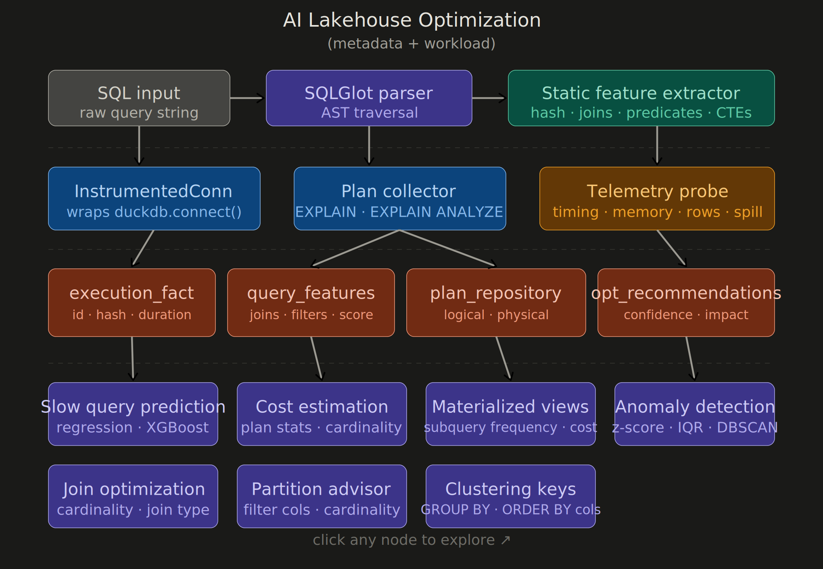
Figure 1. Metadata collection and recommendation architecture.

2.1 SQL Ingestion & Parsing
Raw SQL is parsed with SQLGlot, which traverses the AST to produce a static feature extraction: table and join references, predicate structure, CTE depth, and a query fingerprint hash. This gives a structural fingerprint of every query before it ever executes.

2.2 DuckDB Instrumentation Layer
A wrapped DuckDB connection (InstrumentedConn) transparently intercepts every execute() call. It collects EXPLAIN / EXPLAIN ANALYZE plans through a plan collector, and a telemetry probe captures runtime signal: timing, memory, rows processed, and spill-to-disk events. Because this wraps the connection rather than requiring query rewrites, instrumentation is non-invasive and works with existing application code.

2.3 Metadata Repository
Static and runtime signal are persisted into four tables inside DuckDB’s own storage: execution_fact (per-execution outcomes), query_features (structural features per query), plan_repository (logical/physical plan detail), and opt_recommendations (generated recommendations with confidence and impact scores). This repository is the system’s long-term memory — every optimization decision downstream is grounded in it.

2.4 AI Inference & Recommendation Engine
The repository feeds a set of models and heuristics that turn accumulated metadata into specific, reviewable recommendations rather than raw observability dashboards:
Capability | Input signal | Output
Slow query prediction | Static + runtime features | Probability a query will run slow, before or shortly after execution
Cost estimation | Plan operators, cardinality | Predicted compute cost / credits per query
Materialized views | Subquery frequency, cost history | Candidate views ranked by expected savings
Anomaly detection | Historical baselines (p95, drift) | Flags for queries deviating from normal behavior
Join optimization | Cardinality, join type metadata | Recommended join order / join strategy
Partition advisor | Filter columns, predicate cardinality | Recommended partition / clustering columns
Clustering keys | GROUP BY / ORDER BY columns | Recommended clustering key sets

3. Why a Local-First, DuckDB-Based Approach
Instrumentation is built against DuckDB first rather than directly against a production warehouse such as Snowflake or Databricks. This keeps the experimentation loop fast and free: the metadata schema, feature set, and models can be iterated on locally, against real query workloads, without warehouse credit cost or the friction of a shared environment. The metadata schema is intentionally warehouse-agnostic, so once the approach is validated locally it can be pointed at a production system by swapping the instrumentation layer rather than redesigning the repository or the models.

4. Recommendation Categories
Eight recommendation categories are in scope for the first version of the system, organized in two groups.
- Prediction and estimation: slow query prediction (regression / XGBoost) and cost estimation (plan statistics and cardinality), giving early warning before a query becomes a problem.
- Anomaly detection: statistical baselining (z-score, IQR, DBSCAN) against historical execution patterns to flag queries that deviate from normal behavior.
- Schema-level advisors: join optimization, partition advisor, and clustering key recommendations, each derived directly from observed predicate, join, and grouping patterns rather than generic heuristics.
- Materialized view candidates: identification of repeated, expensive subqueries that are good candidates for materialization, ranked by expected cost savings.

5. Implementation Plan
The work is sequenced so that each phase produces a usable, demonstrable output before the next phase begins.
Phase | Scope | Exit criteria
1 | Build SQLGlot parsing + DuckDB instrumentation layer; persist execution_fact, query_features, plan_repository | Metadata repository populated from a real local workload with no manual intervention
2 | Feature aggregation; first model: slow query prediction + cost estimation | Model recommendations validated against a held-out set of known-slow queries
3 | Remaining advisors: join optimization, partition advisor, clustering keys, materialized views, anomaly detection | All eight recommendation types produce reviewable output on the local DuckDB workload
4 | Port instrumentation layer to a production warehouse (e.g. Snowflake or Databricks) behind the same metadata schema | Recommendations generated against production query history match or beat Phase 3 local results

6. Success Criteria
- Every query executed against the instrumented connection is captured in the metadata repository with no manual logging or developer overhead.
- Recommendations are concrete and reviewable (a specific partition column, a specific join reorder) rather than generic guidance.
- At least one recommendation category demonstrates measurable improvement (reduced query duration, reduced bytes scanned, or reduced compute cost) on a real workload.
- The metadata schema and instrumentation interface require no redesign when ported from DuckDB to a production warehouse.

7. Open Questions
- Which production warehouse should be the first migration target once the local prototype is validated — Snowflake, Databricks, BigQuery, or Trino/Iceberg — and what does that warehouse's own query history API expose natively?
- What confidence threshold should gate a recommendation from “informational” to “actionable,” and who reviews recommendations before they are applied?
- How much historical data is needed before anomaly detection and historical-feature-based models produce reliable signal?

